**RSS Water Balance package – Documentation**

**Author: Amanda Carlson**

**Created: October 30, 2019**

**Description:** A set of functions to implement Dave Thoma’s water balance (WB) spreadsheet model using R scripts. Contains functions to calculate potential evapotranspiration PET from input weather data, and to calculate WB time series using precipitation, temperature, and PET.

Contents

Github Repository 2

Package Contents 2

Functions to Calculate PET 3

Functions to Calculate WB 4

Installation Instructions 5

Input Climate Data and PET Calculation Methods 5

Package Updates 7

# Github Repository

Source files are hosted on github.com/CCRP-Adaptation/WaterBalance/:

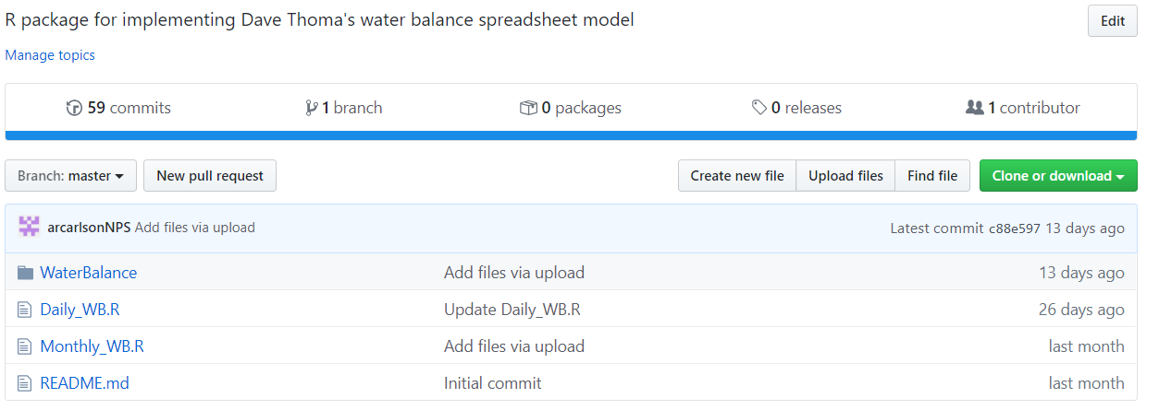

Contents:

* 1. WaterBalance folder = all package files
  2. Daily_WB.R = Script for implementing the WaterBalance package to calculate WB from daily climate data
  3. Monthly_WB.R = Script for implementing the WaterBalance package to calculate WB from monthly climate data

# Package Contents

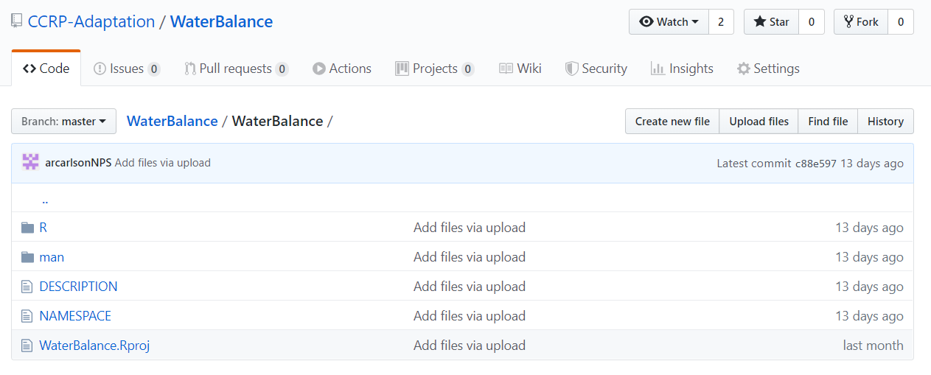

1. ‘R’ subfolder = R files where functions are written
   1. ET_functions.R = Functions for calculating potential evapotranspiration (PET) from input climate data and topographic variables. Contains functions for calculating intermediate variables (e.g., atmospheric pressure, actual vapor pressure) and functions for 3 different methods of PET calculation – Hamon (daily), Thornthwaite (monthly), and Penman-Monteith (daily).
   2. WB_functions.R = Functions for calculating water balance time series variables. Includes all variables calculated in Dave Thoma’s spreadsheet model.
2. ‘man’ subfolder = .Rd files containing function documentation. Documentation files are generated by the document() function in the ‘roxygen2’ package.
3. ‘DESCRIPTION’ and ‘NAMESPACE’ files = Text file created by the document() function in ‘devtools’ package. DESCRIPTION can be edited, do not edit NAMESPACE

# Functions to Calculate PET

Use R help window to see arguments and usage for each function

* get_daylength() – Returns daylength values (in hours) for a given location for a given series of dates. Calls the daylength() function in the ‘geosphere’ package.
* get_svp() – Returns daily saturation vapor pressure values (kPa) for a location given a series of mean daily temperatures (°C).
* get_rh() – Returns the estimated daily relative humidity (%) for a location based on a series of daily vapor pressure (kPa) and mean temperature (°C) values.
* actual_vp() – Returns daily averages of actual vapor pressure (kPa) for a location given daily maximum and minimum relative humidity (%) and daily maximum and minimum temperature (°C) values.
* vapor_curve() – Returns the slope of the saturation vapor pressure curve for given values of mean daily temperature (°C).
* atm_press() – Returns values of estimated atmospheric pressure (kPa) for a location based on elevation (m).
* psyc_constant() – Returns a psychrometric constant (numeric value, no units) based on atmospheric pressure. The psychrometric constant relates the partial pressure of water in the atmosphere to temperature.
* clear_sky_rad() - Returns daily values of incoming clear-sky solar radiation (MJ m-2 day-1) for a location based on the day-of-year (Julian date), latitude (degrees), and elevation (m).
* outgoing_rad() – Returns daily values of outgoing radiation (MJ m-2 day-1) based on daily maximum and minimum temperature (°C), incoming radiation (MJ m-2 day-1), daily mean actual vapor pressure (kPa), and incoming clear-sky radiation (MJ m-2 day-1).
* ET_Hamon_daily() – Uses the Hamon formula to return daily potential evapotranspiration values (mm) for a data frame containing a continuous daily series of daylength values (hours) and mean daily temperatures (°C).
* ET_Thorn_monthly() – Uses the Thornthwaite formula to return monthly potential evapotranspiration values (mm) for a data frame containing a continuous series of year-month values (Date objects), mean temperatures (°C), and average daylength (hours).
* ET_PenmanMonteith_daily() – Uses the Penman-Monteith formula to return daily potential evapotranspiration values (mm) for a data frame containing a continuous series of dates (Date objects), maximum and minimum daily temperatures (°C), and incoming solar radiation (MJ m-2 day-1). Calculations may include additional variables contained in the data frame, including daily maximum and minimum relative humidity (%), vapor pressure (kPa), and/or daily mean wind speeds (m/s). Function inputs also include elevation (m) and latitude (degrees) of the location being calculated, as well as estimated wind speed (single value, if not using daily values).

# Functions to Calculate WB

* get_freeze() – Returns a series of fractional values (0-1) used to partition precipitation into rain vs. snow, based on a series of mean temperatures (°C).
* get_rain() – Returns a series of total rainfall values based on a series of precipitation totals and freeze factors.
* get_snow() – Returns a series of total snowfall values based on a series of precipitation totals and freeze factors.
* get_snowpack() – Returns a series of snowpack depth values based on a series of precipitation totals and freeze factors, as well as an initial snowpack value (default=0). Snowpack calculation is made in time steps, so time series must be continuous.
* get_melt() – Returns a series of snowmelt values (available water from snowmelt) based on a series of snowpack depth values, snowfall totals, and freeze factors. Also accepts an initial snowpack value (default=0). Snowmelt calculation is made in time steps, so time series must be continuous.
* modify_PET() – Adjusts a time series of PET values according for the topography of a location. Arguments include a series of unadjusted PET values (mm), slope (degrees), aspect (degrees), latitude (degrees), and an optional shade coefficient (0-1, default=1). Returns a series of adjusted PET values.
* get_soil() – Returns a series of soil water values based on a series of available water values (rain + snowelt), PET values, maximum soil water-holding capacity (SWC.Max; single value), and an optional initial soil water value (default=0). Input units must match. The user can choose the SWC.Max for any soil depth; output calculations will apply to the selected soil depth.
* get_AET() – Returns a series of actual evapotranspiration values based on a series of available water values (rain + snowmelt), PET values, soil water values, and an optional initial soil water value (default=0). Input units must match.
* get_gdd() – Returns a series of growing degree-days based on a series of mean temperatures and a threshold temperature (must be exceeded for a growing degree-day to be calculated; default=0 °C).

# Installation Instructions

1. Files can be installed from Github using the following R code (requires ‘devtools’):

> install_github("CCRP-Adaptation/WaterBalance", subdir="WaterBalance")

1. Or, the package folder can be downloaded and saved locally (do not rename). Install the package using the following R code (also requires ‘devtools’):

> setwd(<directory where package folder is stored>)

> install(“WaterBalance”)

# Input Climate Data and PET Calculation Methods

1. Climate data may be from any source, but must be formatted before WaterBalance functions can be applied. The current scripts read in tabular data from .csv files, and future versions may pull data from gridded spatial datasets or online servers. Scripts require data in a standardized format, with required columns depending on the PET calculation method. There cannot be gaps in the time series.
2. Input data for available PET methods:
   * 1. Hamon PET at daily time steps:

Required data: Date, precipitation (mm) and Tmean (°C).

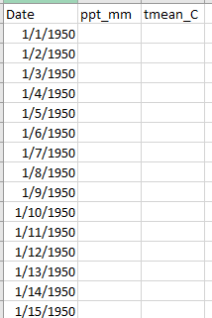

**Column names must match**

**Units must be mm/deg C**

**Dates are a continuous daily time series**

* + 1. Penman-Monteith method at daily time steps:

Required data: Date, precipitation (mm), Tmax (°C), Tmin (°C), solar radiation (MJ m-2 day-1).

Optional data: Max. relative humidity (%), min. relative humidity (%), vapor pressure (kPa), wind speed (m/s).

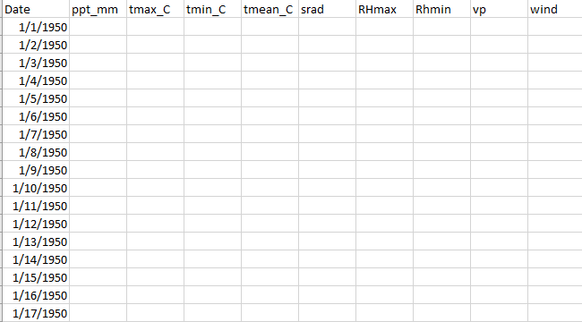

**Optional columns**

**Required columns**

**Column names must match**

**Dates are a continuous daily time series**

* + 1. Thornthwaite method at monthly time steps:

Required data: Date, precipitation (mm) and Tmean (°C)

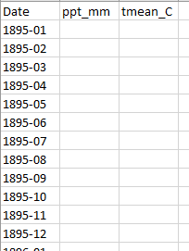

**Dates are a continuous monthly time series**

**Column names must match**

# Package Updates

Package can be updated by adding new .R files containing new data or functions to the ‘R’ subdirectory, or by adding or editing functions in existing .R files. Documentation needs to be regenerated with any updates, or package will not install properly.

Steps to add a new function:

1. Write function with roxygen2 documentation tags (see <https://hilaryparker.com/2014/04/29/writing-an-r-package-from-scratch/> for guidance)

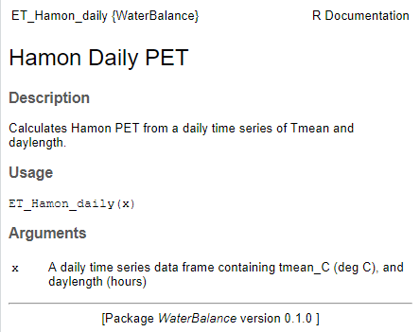**Example:**

**Documentation tags**

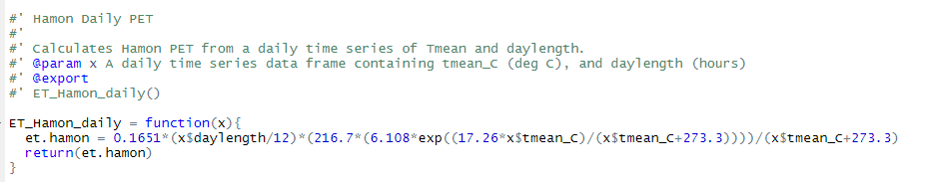

**Use ?ET_Hamon_daily to call documentation in R help window**

1. Set the working directory to the folder where the package folder is stored, then type document() into the command line (requires ‘devtools’). This will generate additional documentation .Rd files in the ‘man’ folder.
2. Reinstall package
3. Update Github – update the .R file in ‘R’ subdirectory and add the new .Rd file to the ‘man’ subdirectory